**Midterm Study Guide**

**Biology Essential Standard 1.1**

**Understand the relationship between the structures and functions of cells and their organelles.**

**Bio.1.1.1 Summarize the structure and function of organelles in eukaryotic cells**:

1. Match these organelles with their functions:
   1. Nucleus 1. Sites of photosynthesis, contain chlorophyll.
   2. Plasma Membrane 2. Powerhouse of the cell, where cell respiration occurs.
   3. Cell Wall 3. Brain of the cell, contains the DNA & chromosomes.
   4. Mitochondria 4. Sites of protein synthesis, where mRNA & tRNA meet.
   5. Vacuoles 5. Cell’s outer boundary, maintains homeostasis, semipermeable.
   6. Chloroplasts 6. In Plants and Prokaryotes, provides support and protection.
   7. Ribosomes 7. Large in plants, used for storage of water and waste.

1. Describe how these organelles interact with each other to perform the function of the cell:
   1. Nucleus and ribosome -
   2. Plasma membrane and mitochondria –
2. Label the plant and animal cell with the above organelles:

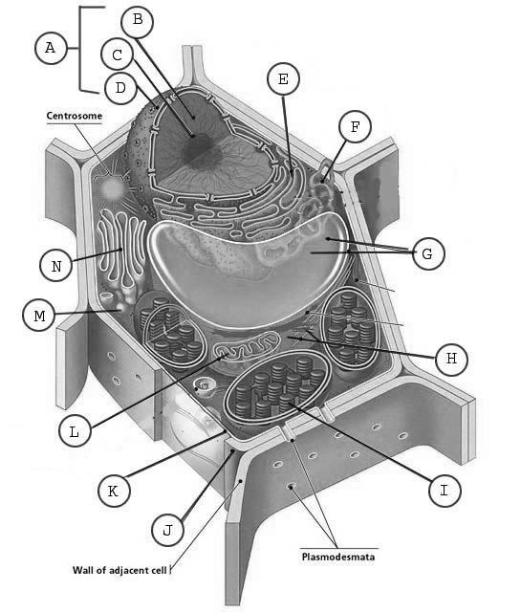

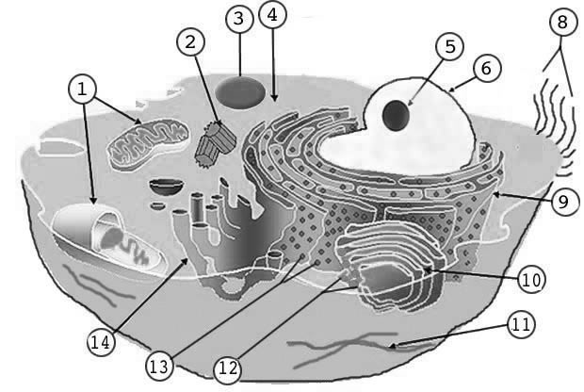

(dots)

1. When using a light microscope, what is the total power magnification if the lens is 10x and the objective is 60x?

**Bio 1.1.2 Compare prokaryotic and eukaryotic cells in terms of their general structures (plasma membrane and genetic material) and degree of complexity.**

5.

* 1. Which are more complex, prokaryotic cells or eukaryotic cells? (circle)
  2. Compare the structure of prokaryotic and eukaryotic cells. Which of these organelles are found in each type of cell? (check which are found in each)

|  |  |  |  |  |  |
| --- | --- | --- | --- | --- | --- |
|  | Mitochondria | Nucleus | Vacuole | Chloroplasts | Ribosomes |
| Prokaryote |  |  |  |  |  |
| Eukartyote |  |  |  |  |  |

|  |  |  |  |  |  |
| --- | --- | --- | --- | --- | --- |
|  | DNA | Genetic material enclosed in nuclear membrane | Plasmids | Smaller cells | Larger cells |
| Prokaryote |  |  |  |  |  |
| Eukartyote |  |  |  |  |  |

* 1. What are shape does bacterial DNA have?
  2. Compare the structure of plant and animal cells. Which of these organelles are found in each type of cell? (check which are found in each)

|  |  |  |  |  |  |  |  |
| --- | --- | --- | --- | --- | --- | --- | --- |
|  | Mitochondria | Nucleus | Cell membrane | Vacuole | Cell wall | Chloroplasts | Ribosomes |
| Plant |  |  |  |  |  |  |  |
| Animal |  |  |  |  |  |  |  |

**Bio 1.1.3 Explain how instructions in DNA lead to cell differentiation and result in cells specialized to perform specific functions in multicellular organisms.**

1. Compare a variety of specialized cells and understand how the functions of these cells vary:

Match these cells with their functions:

* 1. nerve cells 1. Vascular tissue in plants that carry water.
  2. muscle cells 2. Vascular cells that carry oxygen & nutrients & fight disease.
  3. blood cells 3. Cells which send impulses back and forth to brain and spinal cord.
  4. sperm cells 4. The male gamete.
  5. xylem 5. Vascular tissue in plants that carry food.
  6. phloem 6. Cells which flex & extend (contract) to allow movement.

1. Match the cell picture with the cell type.

4.

3.

2.





* 1. Nerve cell

1.





* 1. Muscle cell
  2. Blood cell
  3. Sperm cell

1. Multicellular organisms begin as _____________________________masses of cells and variation in ____________ expression and ____________activity determines the differentiation of cells and ultimately their specialization. (word bank - DNA, gene, undifferentiated)
2. During the process of differentiation, are all parts of the DNA activated?
3. Do all cells in an organism contain the same DNA?
4. Do all cells initially have the potential to become any type of cell?
5. What is the process in which the cell becomes specialized for its particular job? (choose one)
   1. Crossing over b. differentiation c. natural selection
6. What is the name for cells which have not yet differentiated into various cell types? (choose one)
   1. Blood cells b. bone marrow cells c. stem cells
7. How are Embryonic stem cells different from Adult Stem Cells?

**Biology Essential Standard 1.2 and 4.2.2**

**Analyze the cell as a living system.**

**Bio.1.2.1 Explain how homeostasis is maintained in a cell and within an organism in various environments (including temperature and pH).**

**Bio 4.2.2 Explain ways that organisms use released energy for maintaining homeostasis (active transport).**

1. What are some ways your body maintains homeostasis? (give three examples)
2. Compare active vs. passive transport: (check which apply)

|  |  |  |  |  |  |  |  |
| --- | --- | --- | --- | --- | --- | --- | --- |
|  | Diffusion | Low to High Concentration | High to Low Concentration | ATP | Osmosis | With the Concentration Gradient | Against the Concentration Gradient |
| Active Transport |  |  |  |  |  |  |  |
| Passive Transport |  |  |  |  |  |  |  |

1. The movement of particles from an area of high concentration to an area of low concentration without energy being used from the cell: (choose the best choice) diffusion active transport osmosis
2. The movement of water from an area of high concentration to an area of low concentration across the cell membrane without energy being used from the cell is _________________.
3. Can you describe what happens to cells in these different solutions:

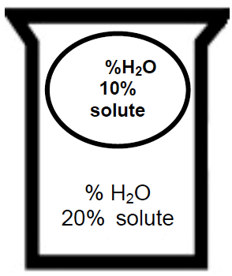

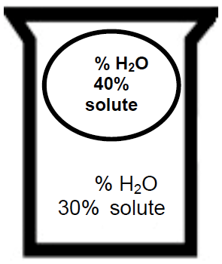

1. Which way will the water move?
2. Will the cell swell or shrink?
3. Which way will the water move?
4. Will the cell swell or shrink?

**Bio.1.2.2 Analyze how cells grow and reproduce in terms of interphase, mitosis and cytokinesis.**

**Bio.3.2.1 Explain the role of meiosis in sexual reproduction and genetic variation.**



20. Before the cell divides what must first happen?

21. When does DNA replication occur?

22. Put the following stages of mitosis (cell division) in order. ____→ ____→ ____→ ____ →____

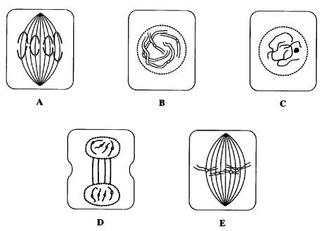

23. How many chromosomes are found in a diploid human cell?

24. If a fruit fly’s sperm cell contains 4 chromosomes, how many chromosomes would there be a fruit fly’s nerve cell?

25. If a bird somatic cell has 20 chromosomes how many would be in the gamete?

**26. Complete the following table:**

|  |  |  |
| --- | --- | --- |
|  | MITOSIS | MEIOSIS |
| Type of reproduction  (Asexual or sexual) |  |  |
| Different or identical cells made? |  |  |
| Chromosome number of daughter cells (haploid or diploid) |  |  |
| Number of cell divisions |  |  |
| Number of cells produced |  |  |

27. Crossing over, fertilization and independent assortment all result in ___________.

**Bio.1.2.3 Explain how specific cell adaptations help cells survive in particular environments (focus on unicellular organisms).**

1. **Match each with their definition/examples:**

|  |  |  |  |  |  |
| --- | --- | --- | --- | --- | --- |
|  | Long whip-like tails that are used in movement | Extensions of the cytoplasm that are used in movement & nutrition. | A photo-sensitive area that detects light. | Pumps excess water out of the cell. Helps maintain homeostasis | Tiny hair-like projections that are used in movement & nutrition |
| Contractile vacuoles |  |  |  |  |  |
| Cilia |  |  |  |  |  |
| flagella |  |  |  |  |  |
| pseudopods |  |  |  |  |  |
| eyespots |  |  |  |  |  |

**Biology Essential Standard 3.1**

**Explain how traits are determined by the structure and function of DNA.**

**Bio.3.1.1 Explain the double-stranded, complementary nature of DNA as related to its function in the cell.**

**Use these words to complete #54:** DNA, double helix, deoxyribose, proteins, cytosine, S phase, base, thymine, phosphate-sugar, hydrogen, covalent bond, nucleus

1. The structure of DNA is a _________________________ or “twisted ladder” structure. The sides are composed of alternating __________________________ groups and “rungs of the DNA ladder” are composed of complementary nitrogenous _______ pairs.
   1. Adenine (A) bonds with _________________________
   2. Guanine (G) bonds with _________________________
   3. Which type of weak bonds holds nitrogen bases together?
   4. The sequence of nucleotides in DNA codes for ___________________, which is central key to cell function and life.
   5. Replication occurs during the ________________of the cell cycle and allows daughter cells to have an exact copy of _______________. It happens in the ______ of the cell.
   6. This _______ bond connects the phosphates to the sugars in nucleotides.
   7. The sugar in DNA is _______________.
2. Write one sentence connecting the following words: Mutation, DNA, Cancer, Mitosis.

**Bio.3.1.2 Explain how DNA and RNA code for proteins and determine traits.**

**Use these words to answer #56:** peptide, transcription, ribose, ribosome, proteins, thymine, tRNA, nucleus, translation, uracil

1. Explain the process of protein synthesis:
   1. _______________________ produces an RNA copy of DNA, and happens in the _______ of the cell.
   2. RNA’s sugar is _______ and it has ______ instead of _________.
   3. mRNA travels to the __________________ (rRNA)
   4. _____________ supplies appropriate amino acids
   5. Amino acids are linked by ______________ bonds to form polypeptides or ________. This process is called____________
2. Complete the problems below: (Use page 292 in the blue book)
   1. What is the complementary DNA to this sequence? AGTCGAGCT
   2. After transcription, what will the RNA be for this DNA sequence? TGCAGC

c. If the DNA sequence is GCATCG, what will the amino acids be?

d. If the mRNA sequence is GCUAGC, what will the protein be?

e. If the tRNA sequence is AGUCGA, What will the amino acids be?

* 1. Examine the Karyotype below. A. What is the gender of this child? B. Which genetic disorder does this child have? C. What is the cause of this disorder?



**Biology Essential Standard 4.1**

**Understand how biological molecules are essential to the survival of living organisms.**

**Bio.4.1.1 Compare the structures and functions of the major biological molecules (carbohydrates, proteins, lipids, and nucleic acids) as related to the survival of living organisms.**

1. Compare the structure and function of each of the listed organic molecules in organisms. Check which are examples or are related to these biological molecules:

|  |  |  |  |  |  |  |  |  |
| --- | --- | --- | --- | --- | --- | --- | --- | --- |
|  | Amino acid | Glucose | Glycerol and 3 fatty acids | nucleotides | Peptide bonds | monosaccharaides | Triglyceride | Phosphate, sugar, base |
| Carbohydrate |  |  |  |  |  |  |  |  |
| Lipid |  |  |  |  |  |  |  |  |
| Protein |  |  |  |  |  |  |  |  |
| Nucleic Acid |  |  |  |  |  |  |  |  |

* 1. Carbohydrates
     1. What is the function of glucose?
     2. What is the function of cellulose and where is it found?
     3. What is starch used for?
     4. What is glycogen and how is it related to starch?
  2. Proteins
     1. What is the function of insulin?
     2. What is the function of enzymes?
     3. What is the function of hemoglobin and where is it found?
  3. Lipids
     1. What is the function of phospholipids/where are they found?
     2. Why are steroids important to our bodies?
  4. Nucleic Acids
     1. What is the function/purpose of DNA and RNA?

**Bio.4.1.3 Explain how enzymes act as catalysts for biological reactions.**

1. Develop a cause and effect model for specificity of enzymes.

Please use this word bank to answer the next questions:

**all, lower, pH, re-usable, lactose, substrate,3-D, speed up, lactase, temperature, active site, specific, catalysts, denaturation**

* 1. The folding of proteins produces a _____________ shape that is linked to function.
  2. Enzymes are proteins that ________________ chemical reactions. Because of this, enzymes are called __________________.
  3. Enzymes _______________ the activation energy of a reaction.
  4. Enzymes are _______________ and ________________.
  5. Enzymes are affected by factors such as __________ and _____________________ and it’s called ____________.
  6. Enzymes are necessary for _________ biochemical reactions!
  7. The substance that fits into the enzyme is called the_______ and it attaches to the enzyme at the __________.
  8. ________is an enzyme which breaks down the sugar _______found in milk.

**Biology Essential Standard 4.2**

**Analyze the relationships between biochemical processes and energy use in the cell.**

**Bio.4.2.1 Analyze photosynthesis and cellular respiration in terms of how energy is stored, released, and transferred within and between these systems.**

1. Analyze overall reactions including reactants and products for photosynthesis and cellular respiration and factors which affect their rates.
   1. Write the equation for photosynthesis.
   2. What are the reactants for photosynthesis?
   3. What are the products of photosynthesis?
   4. Write the equation for cellular respiration.
   5. What are the reactants for respiration?
   6. What are the products for respiration?
   7. How would low levels of carbon dioxide or water affect the rate of photosynthesis?
   8. How would high levels of oxygen and glucose affect the rate of cellular respiration?
   9. How does the amount of light affect photosynthesis?
   10. The xylem carries _______up and phloem carries ________down.
   11. The __________is where carbon dioxide enters the leaf.
   12. The _________is a waxy layer on the leaf which prevents water loss
2. Compare these processes with regard to efficiency of ATP formation, the types of organisms

using these processes, and the organelles involved.

* 1. Which organisms perform photosynthesis?
  2. Which organelles are involved?
  3. Which organisms perform cellular respiration?
  4. Which organelles are involved?
  5. How is anaerobic respiration different from aerobic respiration?
  6. What is another name for anaerobic respiration?
  7. In which organisms does lactic acid fermentation occur?
  8. In which organisms does alcoholic fermentation occur?
  9. How many ATP are produced in aerobic respiration compared to anaerobic respiration?