AP BIO REVIEW ~ UNIT 1 BIOCHEMISTRY

ELEMENTS, COMPOUNDS, ATOMS, MOLECULES, IONS AND BONDS

Matter: anything that has mass and takes up space
Element: matter in its simplest form
Compound: two or more elements combined in simple whole number ratios of atoms
Atom: the smallest form of an element that still displays its particular properties
Consists of
- a nucleus of positively charged protons and neutrally charged neutrons
- an electron cloud of negatively charged electrons
An atom is a neutral particle containing an equal number of protons and electrons
Molecule: a group of two or more atoms held together by chemical bonds
Ion: an atom that has a positive or negative charge
- cation: lost electrons; takes on a positive charge (more protons than electrons)
- anion: gained electrons; takes on a negative charge (more electrons than protons)
Chemical Bonds: form between atoms because of the interaction of their electrons
- electronegativity: the ability of an atom to attract electrons
*plays a large part in determining the kind of bond that forms
- Three major types of bonds to know:
  - IONIC bonds: form betw. two atoms when electrons are transferred from one atom to the other. Occurs when the electronegativities of the two atoms are very different and one atom has a much stronger pull on the electrons than the other atom. One atom gains electrons and has an overall negative charge and the other atom loses electrons and has an overall positive charge – these atoms are ions and the attraction of their opposite charges constitutes the ionic bond. (EX: NaCl)
  - COVALENT bonds: form when electrons are shared between atoms. Occur when the electronegativities of the atoms are similar.
    - Nonpolar covalent bonds: form when electrons are shared equally
Occurs when two atoms sharing electrons are identical, such as O2, when the electronegativities are identical and both atoms pull equally on the electrons.
    - Polar covalent bonds: form when electrons are shared unequally
Occurs when two different atoms have different electronegativities and an unequal distribution of electrons results. The area around the atom with the stronger pull on the electrons produces a negative charge, or pole, near that atom, and the area around the atom with the weaker pull on the electrons produces a positive pole. In H2O, the oxygen atom, with a greater electronegativity, has a stronger pull on the shared electrons than the two hydrogen atoms, creating a negative pole near the oxygen end of the molecule and a positive pole near the hydrogens.
  - HYDROGEN bonds: weak bonds between molecules. Form when a positively charged hydrogen atom in one covalently bonded molecule is attracted to a negatively charged area of another covalently bonded molecule.
(EX: H2O – the positive pole around a hydrogen atom of one H2O molecule forms a hydrogen bond to the negative pole around the oxygen atom of another H2O molecule)

PROPERTIES OF WATER
The hydrogen bonds among H2O molecules contribute to some very special properties for water.
- Water is an excellent solvent. Due to polarity of water molecules.
Substances that dissolve in water are called hydrophilic (‘water loving”)
  - Ionic substances are soluble in water because charged poles of water molecules interact with ions
  - Polar covalent molecules are similarly soluble because of their interactions of their poles with those of water
However, nonpolar covalent molecules do not dissolve in water because they lack charged poles. They are called hydrophobic (“water fearing”)
- Water has a high heat capacity.
Its temperature changes very slowly in response to a gain or loss of heat.
It takes a lot of added energy to heat water or a lot of energy removed to cool it.
Important for living systems:
- The temps of large bodies of water are very stable in response to temp changes of the surrounding air. (Marine life)
- When sweat evaporates from your skin, a large amount of heat is taken with it and you are cooled. (regulation of body temperature)
- Ice floats. Due to hydrogen bonds between water molecules.
Water expands when it freezes and becomes less dense than the liquid form.
(Most substances contract and become denser.) Weak hydrogen bonds become rigid
and form crystals that keep molecules separated. Ice floats and forms an insulating
protection for marine life.
- Water has strong cohesion which produces a high surface tension.
Attraction between like molecules. Due to hydrogen bonds
- Water adheres to other molecules.
Attraction between unlike molecules. Due to hydrogen bonds between water and other
polar covalent molecules. Capillary action of water adhering to walls of narrow tubing
or to absorbent solids like paper.

ORGANIC MOLECULES
Contain carbon → Endless variety of organic molecules.
Carbon’s versatility due to its four valence electrons
– able to form bonds with other atoms
- and itself, in chains, branches, and rings
to create large organic molecules, macromolecules, consisting of 100s and 1000s of atoms
- most are polymers, large molecules consisting of repeats of a single unit (monomer)
Additional variety to carbon molecules comes from presence of N, O, S, P and H atoms.
Functional groups – similar clusters of atoms that give a molecule a particular property.

Functional Group | Structure | Examples | Characteristic properties
Amino group |  | Amino acids | Polar, hydrophilic  Weak bases
Carboxyl group |  | Amino acids  Fatty acids, sugars | Polar, hydrophilic  Weak acids
Carbonyl group |  | Ketones  aldehydes | Polar, hydrophilic
Hydroxyl group |  | Alcohols  Sugars | Polar, hydrophilic
Phosphate group |  | DNA, ATP,  phospholipids | Polar, hydrophilic
Sulfhydryl group |  | Amino acids | Polar, hydrophilic
FOUR IMPORTANT CLASSES OF ORGANIC COMPOUNDS
**You must be able to recognize the structures of these compounds – study the pictures!
- CARBOHYDRATES
- Used by the cells of the body
- in energy-producing reactions
- as structural materials
- Classified into 3 groups according to the number of sugar (saccharide) molecules:
  - Monsaccharide: “simple sugar”
Consists of a single sugar molecule (such as glucose or fructose)
Most impt one: glucose – used in cellular respiration to provide energy for cells
Sugar molecules have formula (CH2O)n where n = 3 to 8
(for glucose, n = 6 and formula is C6H12O6)
Sugars may have same formula but different arrangement of certain atoms that
drastically changes the chemistry of the molecule
(EX: glucose and fructose; alpha-glucose and beta-glucose)
  - Disaccharide:
Consists of 2 monosaccharides joined by a glycosidic linkage.
(EXs: glucose + fructose = sucrose (common table sugar)
glucose + galactose = lactose (sugar in milk)
glucose + glucose = maltose
Formed by losing a water molecule in a dehydration reaction.
  - Polysaccharide:
Consists of a series of connected monosaccharides
A polymer that may contain thousands of glucose monomers.
Four examples – know structure and function of these!
- STARCH – polymer of alpha-glucose monomers
    - energy storage molecule in plants
- GLYCOGEN - polymer of branched alpha-glucose molecules
    - energy storage molecule in animals
- CELLULOSE – polymer of beta-glucose molecules
  - structural molecule in plant cell walls
  - the major component of wood
- CHITIN – similar to cellulose
  - structural molecule in exoskeleton of insects, spiders, shellfish

Example of subtle molecular changes that illustrate dramatic chemical changes:
Alpha-glucose in starch vs. beta-glucose in cellulose
Bond in starch is easily broken down (digested) by humans and other animals
But beta-glycosidic linkage in cellulose can only be broken down by specialized
organisms like bacteria in guts of termites and cows.

- LIPIDS
- Used by the cells of the body
  - as long-term energy stores
  - as building blocks
- Contain a hydrocarbon tail of CH2’s that is nonpolar and repellant to water
- Hydrophobic and insoluble in water
- Three major groups:
  - Triglycerides: include fats, oils and waxes
- Consist of glycerol molecule + 3 fatty acids (- CH chains w/carboxyl group)
- Used as long-term energy stores in cells –provide 2x more energy than carbs
- Vary by number of carbons in fatty acid chains and placement of bonds:

a) Saturated fatty acids:
- Contain only single bonds betw. carbons and thus “saturated” by hydrogens
- Solid animal fats
- “bad fat” – implicated in heart disease and atherosclerosis
b) Unsaturated fatty acids:
- Contain one or more double bonds between carbons and thus fewer hydrogens
- Oils from plants; liquid at room temp; better for you
  - Phospholipids
  - Consist of glycerol molecule + 2 fatty acids + phosphate group (-PO₃²⁻)
  - Fatty acid “tails” are nonpolar and hydrophobic
  - Phosphate “head” is polar and hydrophilic
  - An amphipathic molecule = both hydrophilic and hydrophobic regions
  - Bilayered structures - provide structural foundations of cell membranes
  - Steroids
  - Consist of a backbone of four linked carbon rings
  - Examples include cholesterol – a component of cell membranes
  - As well as the sex hormones testosterone and estrogen

- PROTEINS
- Composed of chains of amino acids – called polypeptide
- Bonds betw. amino acids are peptide bonds
- Proteins differ by number and arrangement of 20 different amino acids
- Each amino acid is a central carbon bonded to an amino group and a carboxyl group and a hydrogen and an R (“remainder”) group that varies among amino acids
- Four levels of structure of a protein:
(1) primary: describes the order of amino acids
(2) secondary: 3-D arrangement caused by hydrogen bonding
producing alpha helix or beta-pleated sheets
form fibrous proteins
(3) tertiary: additional 3-D shaping caused by interactions among R groups such as
hydrogen bonding and disulfide bonds
dominate globular proteins
(4) quaternary: describes a protein assembled from 2 or more separate polypeptides
(EX: globular protein hemoglobin consists of 4 polypeptide chains)
- Proteins can be grouped according to their functions. Some major categories:
(1) Structural proteins: keratin in the hair; collagen in connective tissues
(2) Storage proteins: casein in milk
(3) Transport proteins: those in membranes of cells; O2-carrying hemoglobin in blood
(4) Defensive proteins: antibodies that provide protection against foreign bodies
(5) Enzymes: regulate the rate of chemical reactions

- NUCLEIC ACIDS
- Stores genetic information of a cell in molecules of DNA
- DNA is a polymer of nucleotides
- A nucleotide of DNA consists of a nitrogen base, a 5-C sugar called deoxyribose, and
a phosphate group
- DNA is a double helix, the 2 strands run antiparallel and are paired by hydrogen bonds between bases, bases are T paired with A, and G paired with C
- RNA differs in that the sugar is ribose, base T is replaced by U and pairs with A, and is single-stranded.
- ATP (adenosine triphosphate) is a common source of activation energy for metabolic reactions → more about ATP later!

CHEMICAL REACTIONS in METABOLIC PROCESSES
- 5 types of reactions you should know:
1. Hydrolysis: breaks down compounds by the addition of H2O
2. Dehydration synthesis: 2 compounds are joined together by release of H₂O as a product
3. Endergonic: a reaction that requires an input of energy to occur
4. Exergonic: a reaction that gives off energy as a product
5. Redox: a reaction involving the transfer of electrons, such as occur along the electron
transport chain of the mitochondria during cellular respiration.

- Chemical reactions that occur in biological systems are referred to as metabolism.
  - Catabolism: breakdown of substances
  - Anabolism: synthesis or formation of new substances

- ENZYMES: (This topic is full of essay material. Know it well!)
  - Globular proteins that act as catalysts (activators) for metabolic reactions
  - Catalysts speed up reactions by lowering the activation energy needed for the reaction to take place.
  - Substrate: the substance(s) that enzymes act on
  - Enzymes are substrate-specific. (Selective – only interact w/specific substrate.)
  - The shape of the enzyme – its quaternary structure – provides the specificity.
  - Active site of enzyme is specific for substrate that fits it shape
  - Induced-fit model: Active site of enzyme is induced to change its shape when substrate binds
  - Enzymes are unchanged as a result of the reaction. Can find and react with another substrate – so only need a small amount of enzyme
  - Efficiency of enzyme is affected by temperature and pH
Each enzyme has its own optimal temp and pH
Enzymes become denatured (lose 3-D shape) at non-optimal temps and pH
- Standard suffix for name of enzyme is –ase
- Effectiveness of enzymes can be affected by four things:
  - temperature
  - pH
  - the concentration of the substrate
  - the concentration of the enzyme
- REGULATION OF A CHEMICAL REACTION IN LIVING SYSTEMS
→ REGULATE ITS ENZYME!
  - Competitive Inhibition: a substance that mimics the substrate binds to the active site and physically blocks the substrate from attaching.
    - Can be overcome by adding a large concentration of substrate to outcompete the inhibitor
  - Noncompetitive Inhibition (Allosteric Inhibition): a substance binds to a site other than the active site of the enzyme, causing a change in the shape of the active site so that it can no longer interact with the substrate.

pH: ACIDS AND BASES
pH scale:
- indicator of how acidic or basic a solution is
- ranges from 0 to 14 with 7 as neutral, 0 – 7 acidic and 7 – 14 basic
- a logarithmic scale -- so a pH of 3 is 10 times more acidic than a pH of 4
(and 100 times more acidic than a pH of 5, 1000 times more acidic than a pH of 6….etc)
- except for reactions involving enzymes of the digestive system, chemical reactions in humans function at a neutral pH
Unit 2: The Cell

Hierarchy of Life:
Largest
Biosphere- All environments on Earth that supports life, land, water, etc
Ecosystem- All organism in a particular area including non-living things. Eg. African Savanna
Community- All living things in an area. Eg Lions, Zebra, Hippos, etc.
Population- All of the individual species in a community. Eg. Lions
Organism- A single being in a population. Eg. A single lion cub
Organ system- All the systems in the organism. Eg. Circulatory system, Nervous system etc.
Organ- Parts of the organ system that work together. Eg. Brain
Tissue- Parts of an Organ with specific jobs. Eg. Nervous tissue
Cell- tiny microorganisms that make up tissues. Eg. White blood cells, red blood cells.
Organelle- parts inside the cell the help the cell function. Eg. Nucleus
Molecule- A cluster of atoms held together by chemical bonds.
Smallest

Eukaryotic Cell- Cells that have a membrane bound nucleus. Animal/ Plant cells.

Cell Organelles
Organelle | Function
Nucleus | Part of the cell where DNA is stored and created.
*Nuclear envelope | Membrane enclosing the nucleus.
*Nucleolus | Structure in the nucleus where ribosomes are created.
*Chromatin | Materials consisting of DNA and proteins; visible in a dividing cell.
Plasma membrane | Bilipid layer that surrounds the cell. Acts as a barrier.
Ribosomes | Make protein by reading RNA provided by the nucleus.
Golgi Apparatus | “warehouse” organizes, sorts, and ships products.
Lysosome | Digestive organelles that “eat” and breaks down anything that enters the cell
Mitochondria | Makes ATP (cellular respiration)
Peroxisome | Help break down fatty acids and detoxifies substances in the body.
Microvilli | Projections from the cell that increase cell surface area
Cytoskeleton | Reinforces cell shape, helps in movement
Centrosome | Region where microtubules begin
Flagellum | Long microtubules twirled. Used mostly to help in movement
Rough ER
Smooth ER | Creates lipids and carbs. Detoxifies drugs and poisons and stores calcium ions.
Microtubules  These are a family of tubules They are all hollow | Helps with structure and intercellular transport.
Intermediate filaments | Shorter than microtubules. Same function.
Microfilaments | Thinnest of the 3, more flexible, thinnest of the three
Cell wall  These are extras only found in plant cells. | Outer layer that maintains cell’s shape. More rigid than cell membrane.
Plasmodesmata | Cytoplasmic channels that are connected to other cells
Chloroplast | Photosynthetic organelles that convert light energy to sugar molecules.
Central Vacuole | Storage breakdown to waste products and can store large amounts of water.

Diffusion:
Natural process in which equilibrium need to be met. Substances always GO DOWN their concentration gradient.

Osmosis- Diffusion of water.

Hypertonic- cell will lose water. Eg. the surrounding has a high concentration of salt, water will diffuse out of the cell.

Hypotonic- Cell will gain water. Eg. the surrounding has a lower concentration of salt, water will diffuse into the cell.

Active Transport:
Process that uses energy to move solutes across the membrane, an important process that allows substances from outside of the cell enter the cell.

Active transportation involves proteins in the membrane to move the substance over.

Eg. Proton pump that uses ATP to move H⁺ ions out of the cell to attach with sucrose and diffuse back into the cell. Pg. 137

Enzymes:
Enzymes are used to lower the activation barrier on reactions and speed up reactions. This makes reactions use less amount of energy and hence create less heat.

Enzymes have an active site where a substrate will attach into and cause it to change its shape allowing the enzyme to change the substrate. Eg. on page 155.

I skipped over a lot of stuff here. None of it was part of the review guide from Mrs. Groch so I decided that it was a waste to read it again. If you like to read I skipped all of Ch 8 except enzymes.
Cellular Respiration:

Key terms in this section:
ATP- Adenosine Triphosphate it the form of energy used in our body.
ADP- Adenosine Diphosphate the lack of the phosphate group removes one election making it contain no useable energy
NADH- Think of these as buses (Thanks Mrs. Groch). They carry electrons on them to the ETC.
FADH₂- They are a different form of buses but have the same function.
NAD⁺- These are NADH without elections on them so the are empty buses.

Fermentation- degradation of sugars and other organic fuel that occurs without oxygen.

Aerobic respiration- Oxygen is consumed to created ATP

IMPORTANT EQUATION: C₆H₁₂O₆ + 6O₂ ↔ 6CO₂ + 6H₂O + Energy

All occurs around and inside the mitochondria.

Glycolysis → Pyruvate Oxidation → Citric Acid Cycle → Oxidation Physphorylation: Electron Transport and Chemiosmosis

Glycolysis: Uses energy to create Pyruvate

Put in | Net gain- MOST IMPORTANT
Glucose  4 ATP – 2 ATP used  2 NAD⁺ + 4e⁻ + 4H⁺ | 2 Pyruvate + 2 H₂O  2 ATP  2 NADH + 2 H⁺

Pyruvate Oxidation: When pyruvate enters the mitochondria it is converted into acetyl CoA
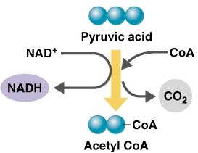
Easier if it’s visual

Citric Acid Cycle or Krebs Cycle:

This is possibly the scariest looking thing in the chapter but a few important things to get out of here.

It has 8 steps where the cycle is simply taking the energy from Acetyl CoA and placing the in NADH or FADH.

The results of the cycle is 6 NADH and 2 FADH₂. These both then take the electrons to ETC.

Electron Transport Chain:

In the electron transport chain the electrons from NADH and FADH₂ are deposited into proteins.

These electrons then jump from one protein to another causing hydrogen ions to go into the intermembrane space. This is all. The difference between FADH₂ and NADH is their docking cite on the ETC.

Chemiosmosis (AKA cootie-catcher):

This is where majority of the ATP is created. There is a rotator protein in the between the intermembrane space and the Mitochondrial Matrix. Here the Hydrogen ions move back into the mitochondrial space.

They go through the rotator protein which has 1 ADP and 1 phosphate group ready to join. The hydrogen ion going through the rotator protein causing it to turn and causes the ADP and Phosphate to join, creating ATP.

This is in the mitochondria’s cell membrane. NEVER GOES INTO THE OUTER CELL MEMBRANE. AGAIN ALWAYS IN THE MITOCHONDRIA!

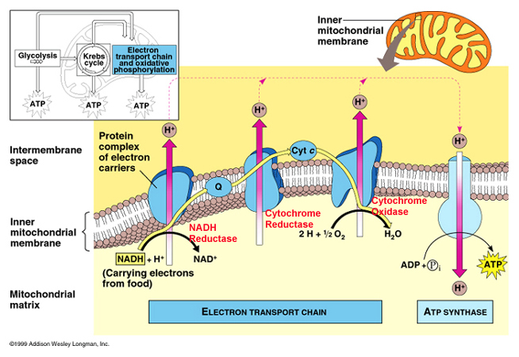

Products | Byproducts
30-32 ATP | CO₂

C₆H₁₂O₆ + 6O₂ ↔ 6CO₂ + 6H₂O + Energy

Photosynthesis:

Occurs in the mitochondria like structure: Chloroplast.

Chloroplast consists of thylakoids where the creation of energy actually takes place.

The equation C₆H₁₂O₆ + 6O₂ ↔ 6CO₂ + 6H₂O + Energy is now reversed in photosynthesis to 6CO₂ + 6H₂O + Energy ↔ C₆H₁₂O₆ + 6O₂ .

As seen here we know that plants require CO₂ and H₂O to survive. The Energy used here is light energy from the sun.

Light Reaction → Calvin Cycle

Light reaction:

Occurs in the thylakoid membrane where light receptors accept light energy.

The receptors excite an electron and the energy is transferred to another receptor till it finally reaches the special pair of chlorophyll a receptors who finally boost it to the primary electron acceptor.

The special pair of chlorophyll a receptors are dubbed P680 because they absorb light best at wavelength 680.

That is Photosystem II. The electrons are then passed to Photosystem I. The photosystems were named in order of their discovery but Photosystem I occurs first in the process.

From the primary acceptor in Photosystem II the electrons go through a electron transport chain, in which ATP is created, into photosystem II P700, the double receptors best are receiving wavelength 700.

In photosystem I the electron from PS II is attached to a NADPH and sent to the Calvin Cycle.

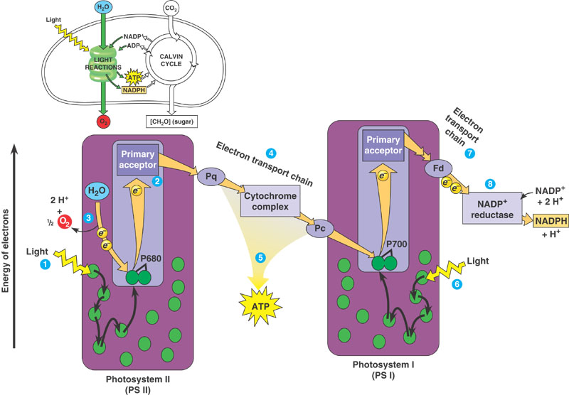

Calvin Cycle:

The function of the Calvin Cycle is to create Glucose and other organic compounds.

Phase 1- Carbon Fixation: 1 CO₂ is attached to a Rubisco molecule. Unlike the Citric Acid Cycle where ATP is created, ATP is used in the Kelvin cycle.

Phase 2- Reduction: with the addition of ATP the structure of Rubisco is changed and finally glucose (sugars) is created.
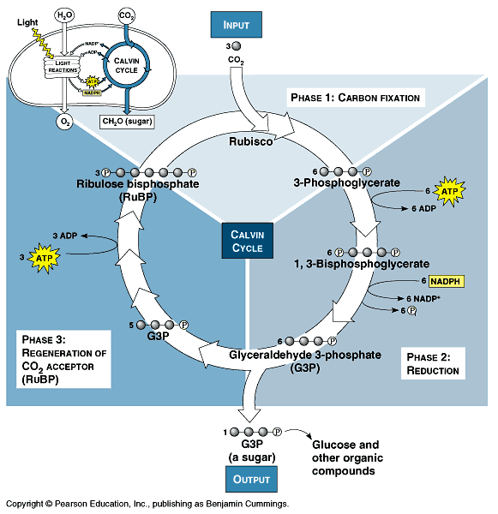
Input | Output
Rubisco  CO₂  6 ATP | Sugars  6 NADPH  6 NADP⁺  6 Phosphates

ATP Synthase:

The way ATP is created. By products of Photosynthesis II O₂ and H⁺ move to another rotator protein in the membrane where the products go down their gradient, outside the thylakoid, causing the rotator protein to rotate.

Like in the Mitochondria membrane, this rotation causes ADP and Phosphate group to join creating ATP.

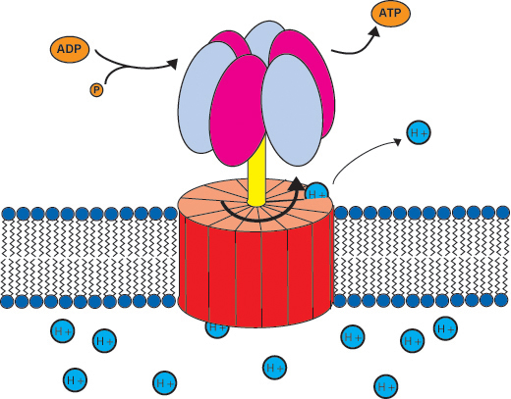

WORKS FOR BOTH PLANTS AND ANIMALS!

C₄ Plants:

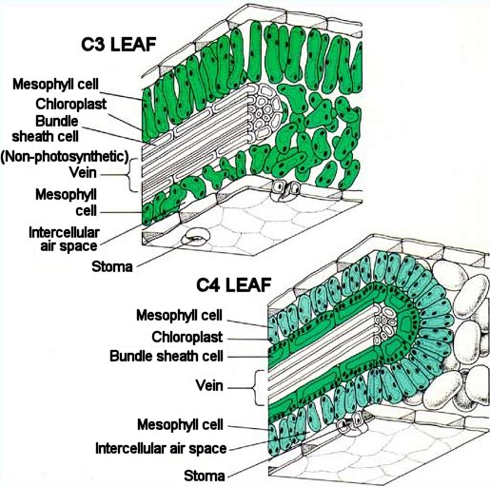

First notice that there is an extra layer, the bundle sheath cell, where C₄ plants work.

They prefer a different way rather than the Calvin Cycle.

Step 1. Occurs in mesophyll cells. First PEP carboxylase (enzyme) adds CO₂ to PEP forming oxaloacetate. PEP has a higher affinity to CO₂ and can use CO₂ when CO₂ is in much less quantitate.

Step 2. Occurs in Bundle Sheath Cell. 4 carbon product from the first step to step 2.

Step 3. Occurs in Bundle Sheath Cell. Releases CO₂ which is sent back into the Calvin Cycle for rubisco to use. Also pyruvate is created which is sent back to the PEP cycle. Then the cells only conduct Photosystem I not Photosystem II.

Steps 1, 2, 3 are on the picture.

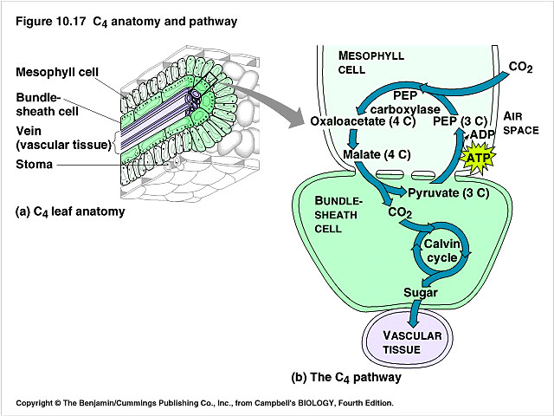
1
2
3

Input | Output
CO₂  PEP | Sugar  Pyruvate (used for normal Calvin cycle)

Main Difference: The main difference is that C₄ plants use PEP instead of rubisco. The difference is that rubisco requires a larger amount of available CO₂ while PEP can be used when CO₂ is in smaller amounts.

CAM Plants:

Usually desert plants, these plants open stomata at night while closing them during the day. This helps store water.

CAM: Crassulacean Acid Metabolism

CAM plants take in CO₂ at night and store them till the day.

During the day they use the sun energy to produce sugars like normal C₄ plants.

While in C₄ plants the two steps are done during the same time but in different cells, CAM plants do the steps at different times of the day but in the same cell.

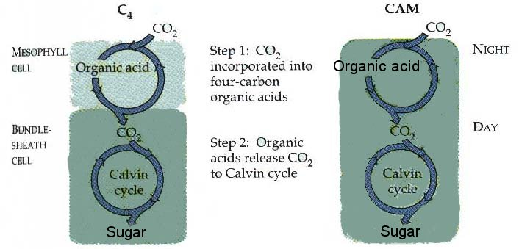

Conclusion:

Normal | C₄ | CAM
Rubisco | PEP | ??
Calvin Cycle | Calvin Cycle  Have extra Bundle-sheath cell | Day and night difference  Occurs in same cell.

- Explain the difference between the following & provide an example of each:
a. genotype & phenotype

b. homozygous & heterozygous

c. recessive & dominant

d. complete dominance, incomplete dominance, and codominance

e. true breed & hybrid

f. autosome & sex chromosome

g. allele, gene, and homologous chromosome

h. chromosome vs. sister chromatid

i. law of segregation vs. law of independent assortment

j. polygenic inheritance vs. multiple alleles

k. sex-linked vs. linked

l. haploid vs. diploid

m. monohybrid vs. dihybrid

- Answer the following questions about Mendel’s P, F1, and F2 generations.
- What does each stand for?
  - P
  - F1
  - F2
- What was crossed in each generation?
  - P
  - F1
  - F2
- What was the genotype/phenotype ratio of the offspring in each generation (there is space below each if you need to do the Punnett squares)?
  - P

  - F1

  - F2

- What type of cross showing complete dominance would in a 3:1 phenotypic ratio? Show the Punnett square.

- If a trait for free earlobes is autosomal recessive, and a female has free earlobes, what is her genotype? What is her phenotype?

- Can a male be a carrier of an autosomal recessive disorder? Why?

- Is it possible for a male or female to be a carrier of an autosomal dominant disorder? Why?

- A cross was done between 2 flowers exhibiting incomplete dominance and all of the offspring were pink.
- Draw a Punnett square showing this crossing. Questions about this Punnett square on next page.

- What are the genotypes of the parents?
- What are the phenotypes of the parents?
- What is the genotypic ratio?
- What is the phenotypic ratio?
- If you were to cross two roan (red and white) cattle, what would be the chances of the offspring having a red phenotype (assuming the gene exhibits codominance)? Show the Punnett square.

- Answer the following questions about the dihybrid cross of DdEe X DdEe.
- Perform the Punnett squares.

- How many of the offspring would be dominant for both traits?
- How many of the offspring would be ddee?
- What is the phenotypic ratio?

- What fraction of the offspring would have the genotype aabbcc if we were to cross AaBbCc x AaBbCc? Show the Punnett squares.

- If a female that is colorblind (a sex-linked recessive trait) and is crossed with a normal male, what genotypes and phenotypes would be possible in the offspring?

- Why are sex-linked traits expressed more in males? Why can't males be carriers of a sex linked trait?

- What are the possible genotypes for the following blood types?
Blood Type | Genotype
A
B
AB
O
- Could a child with type O blood have a father with type AB blood? Why? Show the Punnett square.

- If a woman with type A blood had a child with a man that had type B blood, what are all the possible blood types that the child could have? Show the Punnett square. (There are multiple Punnett squares that could be made, but one particular Punnett square would show all the possible offspring).

- What types of blood can the following individuals accept in a blood transfusion?
Blood Types: | Types they may receive:
A
B
AB
O
- Why can't people with type O blood receive blood from anyone but other with type O?

Use the pedigree below to answer questions 19
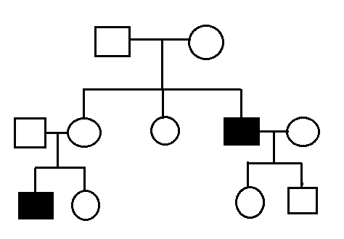
- Answer each of the following with regard to the pedigree above.
- Label the generations and individuals for the pedigree.
- Is the pedigree showing an autosomal or sex-linked trait? Explain.

- Is the pedigree showing a recessive or dominant trait? Explain.

- Write the genotype for each individual under their symbol. If there is not enough information to determine the phenotype of an individual then put a ? for the 2nd allele.
- Individual 1 in generation III mates with a female who is a carrier for colorblindness (hint: this helps give you the answer to b).
    - Draw this female into the pedigree.
    - Create a Punnett square predicting the offspring of these 2 individuals.

    - What percentage of their offspring would be expected to be colorblind?
- Individual 3 in generation III mates with a normal male.
- Draw this male into the pedigree.
- Create a Punnett square predicting the offspring of these 2 individuals.

- What percentage of their offspring would be expected to be colorblind?
- Explain why polygenic traits (like hair color, eye color, height, etc.) result in a range of hundreds of possible phenotypes rather than a few possible phenotypes like the other types of inheritance we have discussed.

- What is an example of linked traits, and why are these inherited together?

- Circle the multiple choice answer for the following pedigree. Then answer the questions that follow.
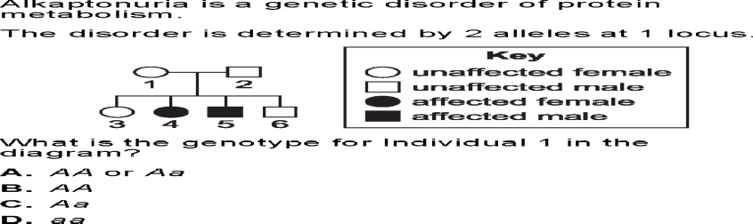
  - How could you tell that this pedigree was for an autosomal trait instead of a sex-linked trait (even if it hadn’t told you by the multiple choice answers)?

  - How could you tell that this pedigree was showing the inheritance of a recessive trait and not a dominant trait?

- Circle the multiple choice answer for the following pedigree. Then answer the questions that follow on the next page.
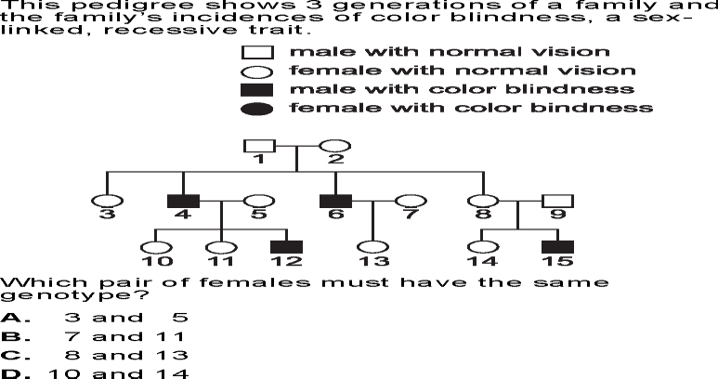
- How could you tell that this pedigree was for a sex-linked trait instead even if the question hadn’t told you (from pedigree on last pg)?

- How could you tell that this pedigree was showing the inheritance of a recessive trait and not a dominant trait even if the question hadn’t told you (from pedigree on last pg)?

- Genetic disorders occur when the number of chromosomes remains the same (46), but the ORDER OF THE DNA BASES creates health problems. Describe the symptoms of the following disorders.
  - Autosomal dominant disorders:
    - Huntingtons

    - achondroplasia

  - Recessive
    - sickle-cell

    - cystic fibrosis

  - Sex-linked recessive
    - Hemophilia

    - Colorblindness

- Genetic syndromes occur when the normal number of chromosomes is altered because of problems during anaphase of meiosis. Answer the following questions about these scenarios.
- All of these syndromes are caused by nondisjunction of homologous chromosomes or sister chromatids during meiosis. What is nondisjunction?

- What phase of meiosis does this occur in?
- Explain how the karyotypes of each of the following syndromes would look different than a normal karyotype. In other words, where would they have an extra or missing chromosome.
- Down syndrome

- Turner’s syndrome.

- Klinefelter’s syndrome.

- Why can’t we tell if someone has a genetic disorder (i.e. colorblindness, Huntingtons, etc.) just by looking at karyotype?
d. What are the characteristics of individuals with the following syndromes?
- Down syndrome

- Turner’s syndrome.

- Klinefelter’s syndrome.
Cell Cycle

- Compare and contrast the role of cell division in unicellular and multicellular organisms.
- You must know this vocab so define the following terms:

  - Genome
  - Chromosomes
  - Somatic cells
  - Gametes
  - Chromatin
  - Sister chromatids
  - Centromere
  - Mitosis
  - Cytokinesis
  - Meiosis

  - Mitotic spindle
  - Centrosome
  - Microtubule organizing center
  - Aster
  - Kinetochore

- What happens in each phase of the cell cycle below?

  - Mitotic phase
  - Interphase
  - G1 phase
  - G2 phase
  - S phase
- How is cytokinesis different in plant vs.animal cells?
- Identify the phases of cell division: (label the structures seen in the phases)
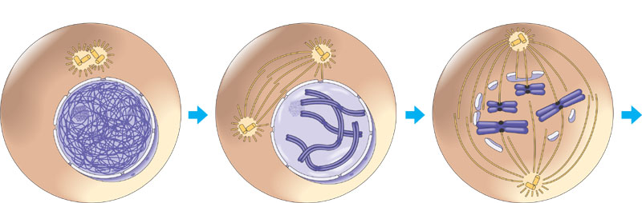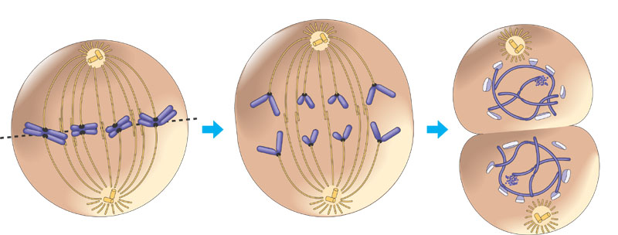

- Why would a cell no longer divide?

- Label the diagram below:
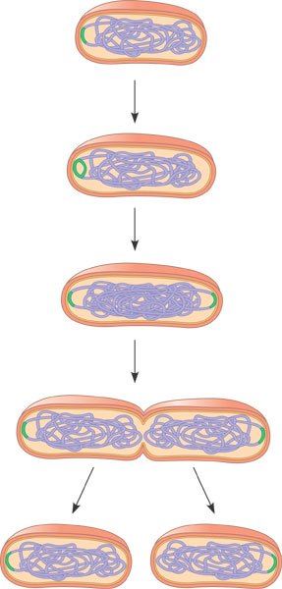
- How is the cell cycle controlled?

- Describe how cells exhibit anchorage dependence.

- What is cancer?

- How do the following terms relate to cancer?

  - Benign tumor
  - Malignant tumor
  - Metastasis

Meiosis

- Compare and contrast asexual and sexual reproduction.
- Define the following terms:

  - Life cycle
  - Karyotype
  - Homologous chromosomes
  - Sex chromosomes
  - Autosomes
  - Diploid cell
  - Haploid cell
  - Fertilization
  - Zygote
  - meiosis

- What are the two broad goals of meiosis?

- How does the chromosome number change during the process of meiosis?

- Label the following diagrams of meiosis.
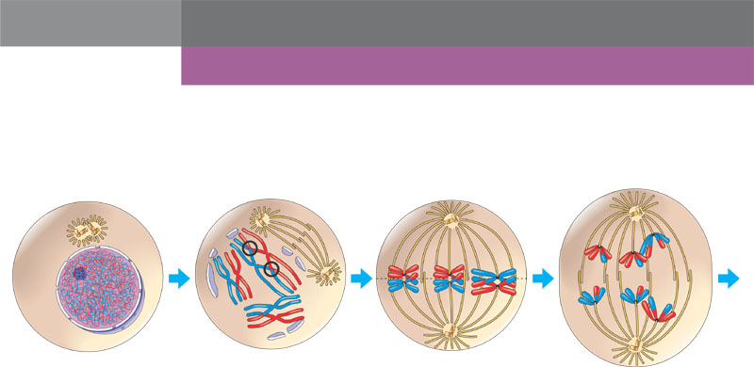
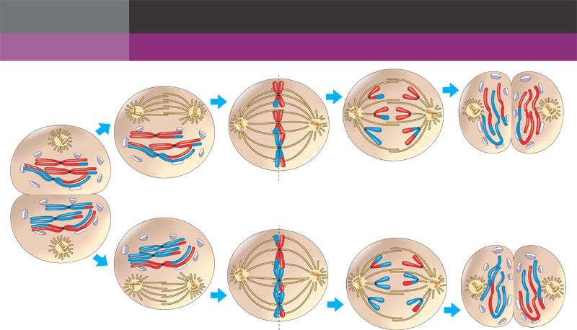

- Compare and contrast mitosis and meiosis.
- Describe in detail the three sources of genetic variation in meiosis.

